

**Pampanga State University**

**Apalit Campus**

**Game Development Documentation**

**" UNDYING MARCH "**

*Submitted by: Aniciete, Mark Adrian V. (Project Manager)*

*Ramos, Angelo Norman L. (Programmer I)*

*Pacios, Danniel S. (Programmer II)*

*Mariano, Mark Jeremy M. (Designer I)*

*Eduardo, Ace Paul R. (Designer II)*

BSIT-2B

*Submitted To:* *Ric Montemayor Torregoza*

**Introduction**

This documentation presents the development and implementation progress of the game titled *Undying March*. The purpose of this paper is to validate and provide evidence that all tasks have been properly planned, monitored and executed within the given timeframe with the help of Gantt Chart, ensuring consistent progress for the project's weekly development to meet its completion.

**Objectives**

For this week's progress, the following tasks have specific start date and end date for the duration of the task to be accomplished, the objectives are listed below:

October 31, 2025 - November 2, 2025

• Enemy Patrol – Applying a patrol behavior to the enemy as a default behavior.

• Chase – Applying a chase behavior to the enemy so it will chase the main character.

• Line of Sight – Applying LOS to the enemy so that it will chase the main character if he is in visible sight range.

**Documentations**

**Tasks Implemented**

**Task ID:** 5

**Task:** Enemy Patrol, Chase, Line of Sight

**Start Date:** October 31, 2025

**End Date:** November 2, 2025

For this task, our Programmers deployed the enemy npcs and applied a patrol logic wherein the enemy npcs will move randomly within an area to patrol, while patrolling it can detect our main character by either using two logics, first is breadcrumbs and 2nd is line of sight, upon detecting the main character, the enemy npcs will chase it.

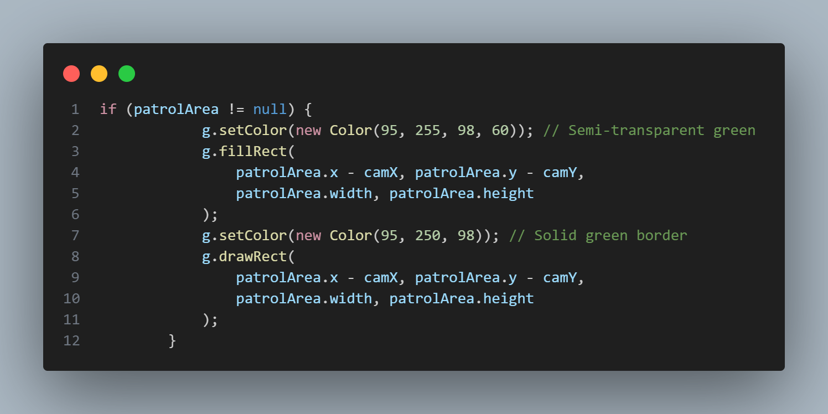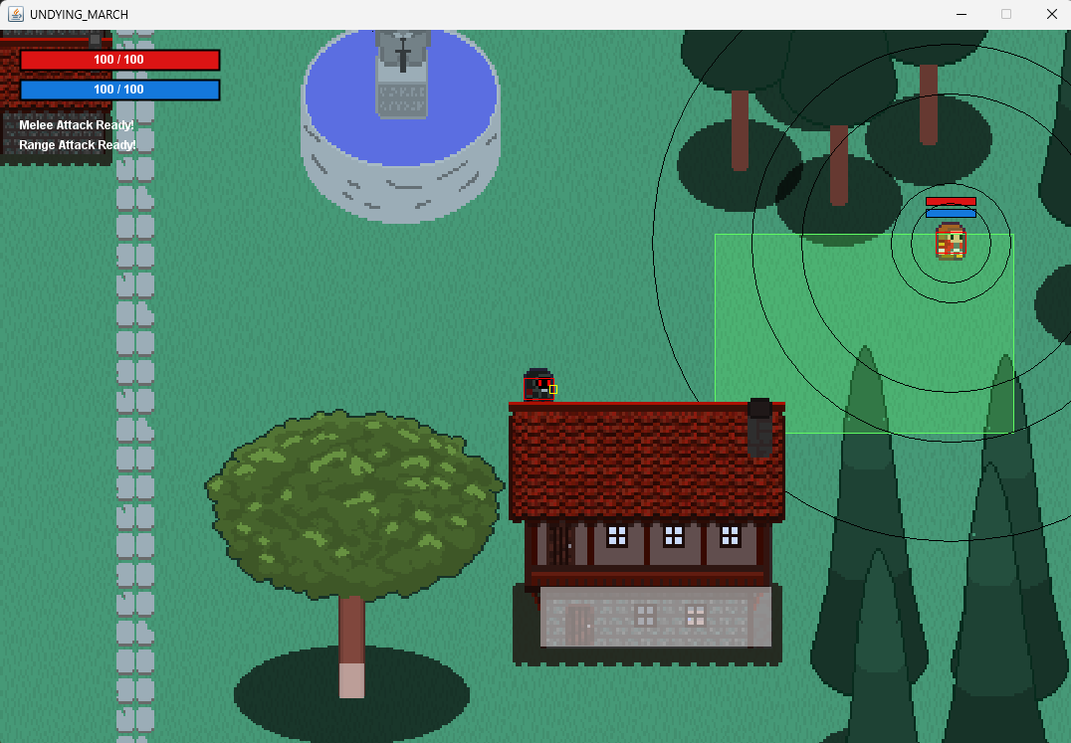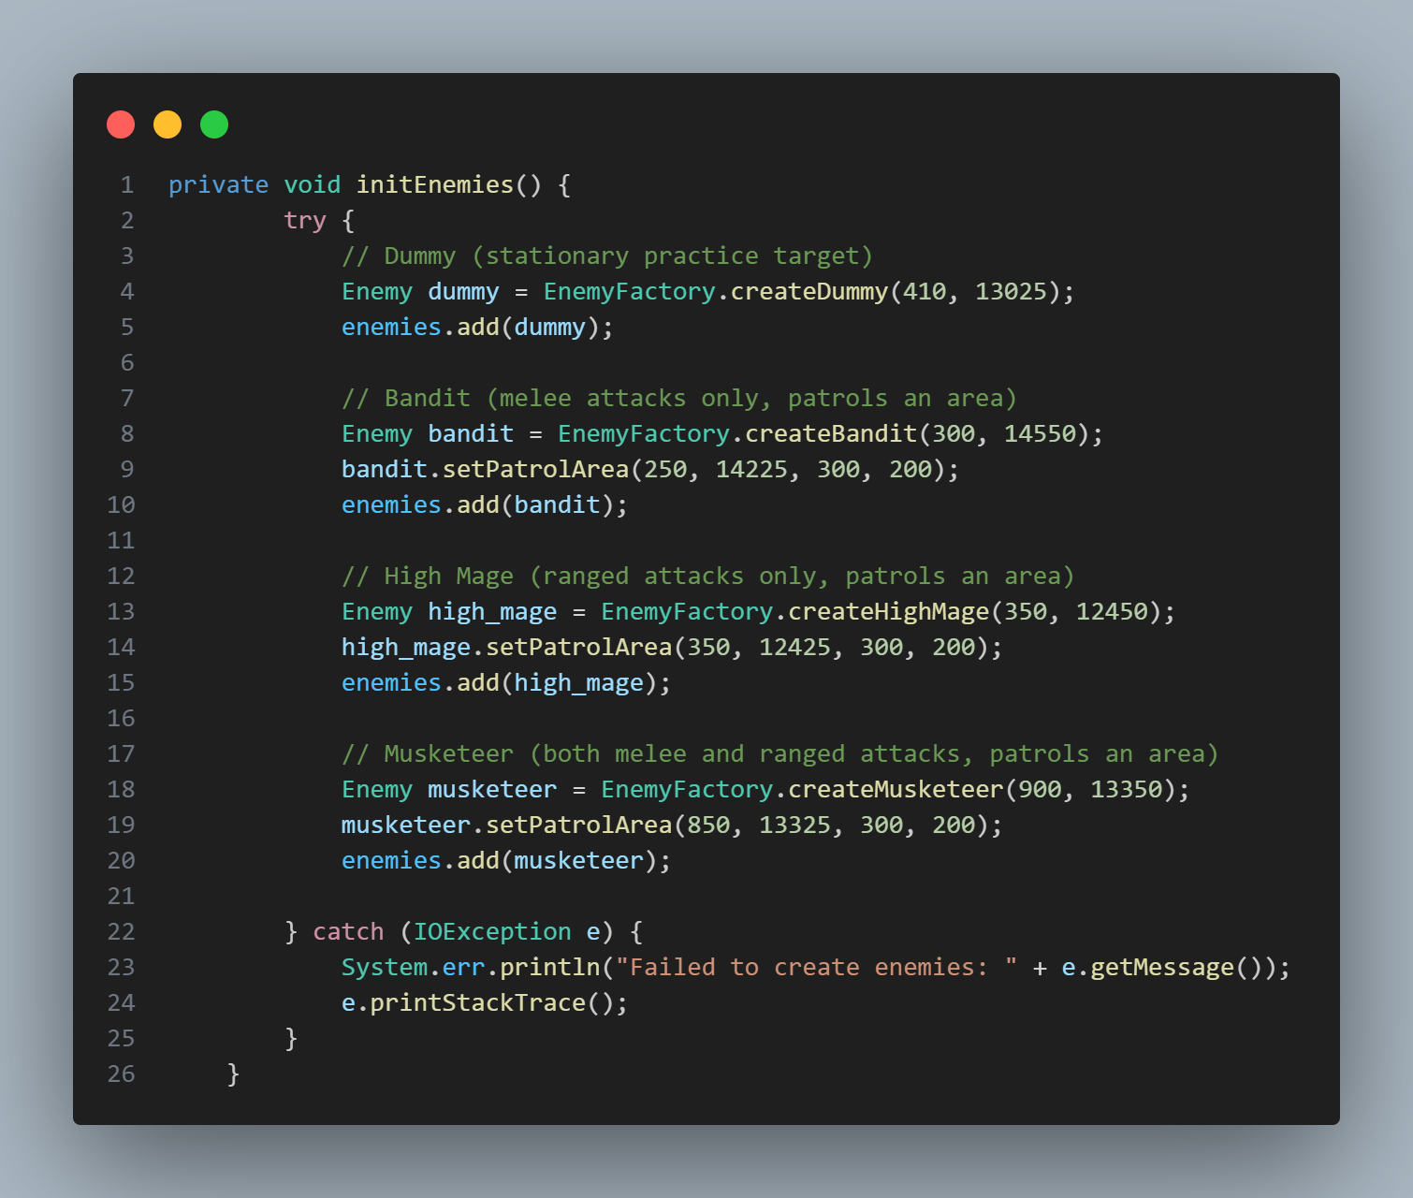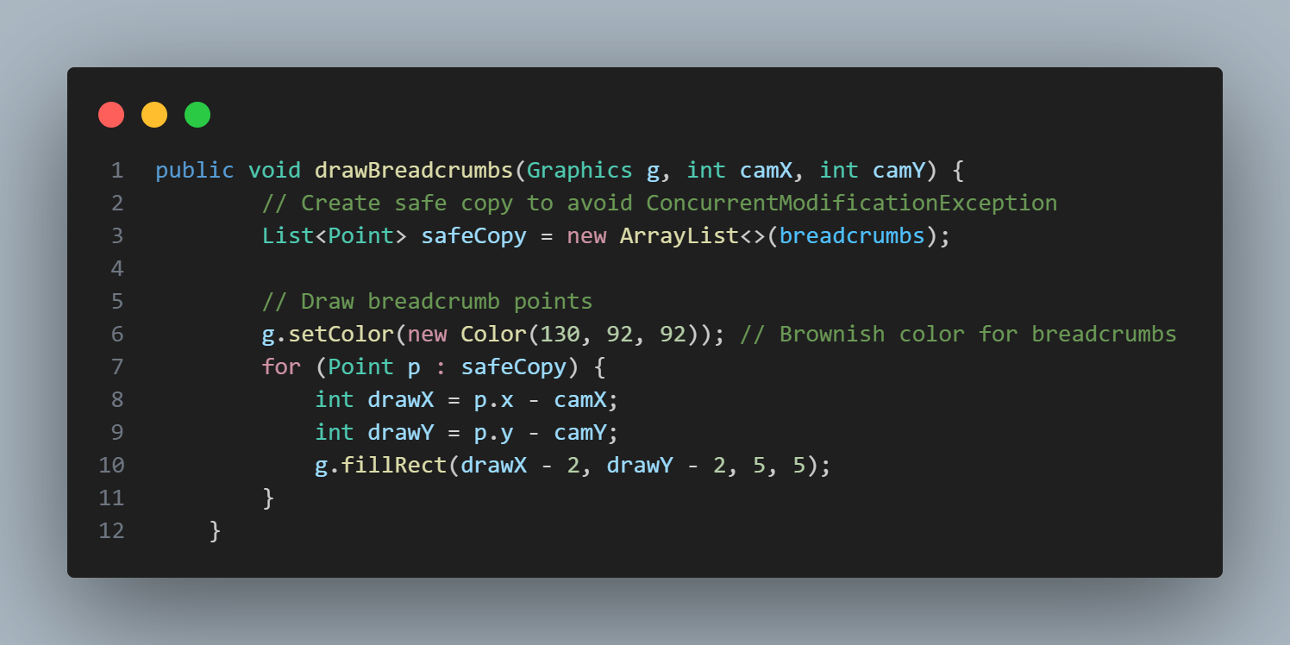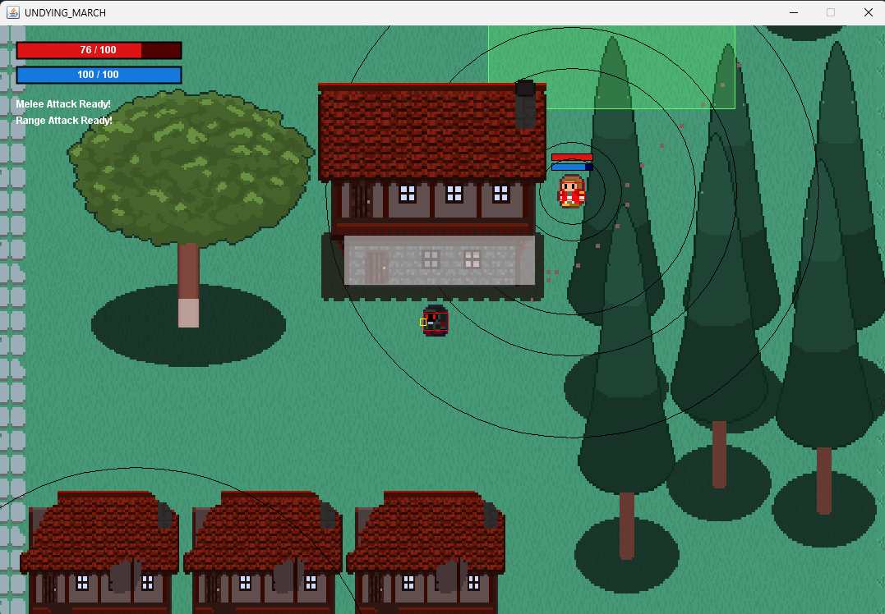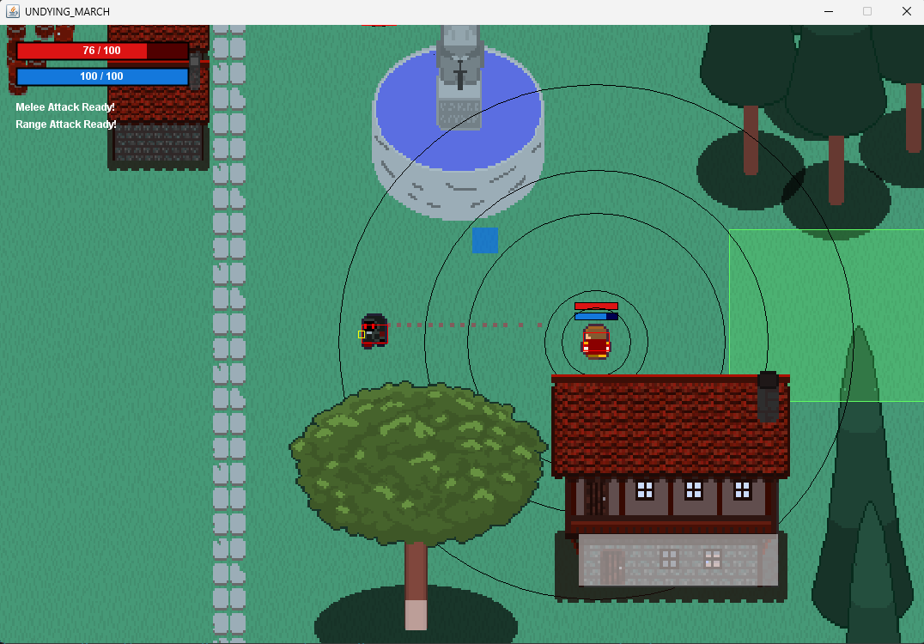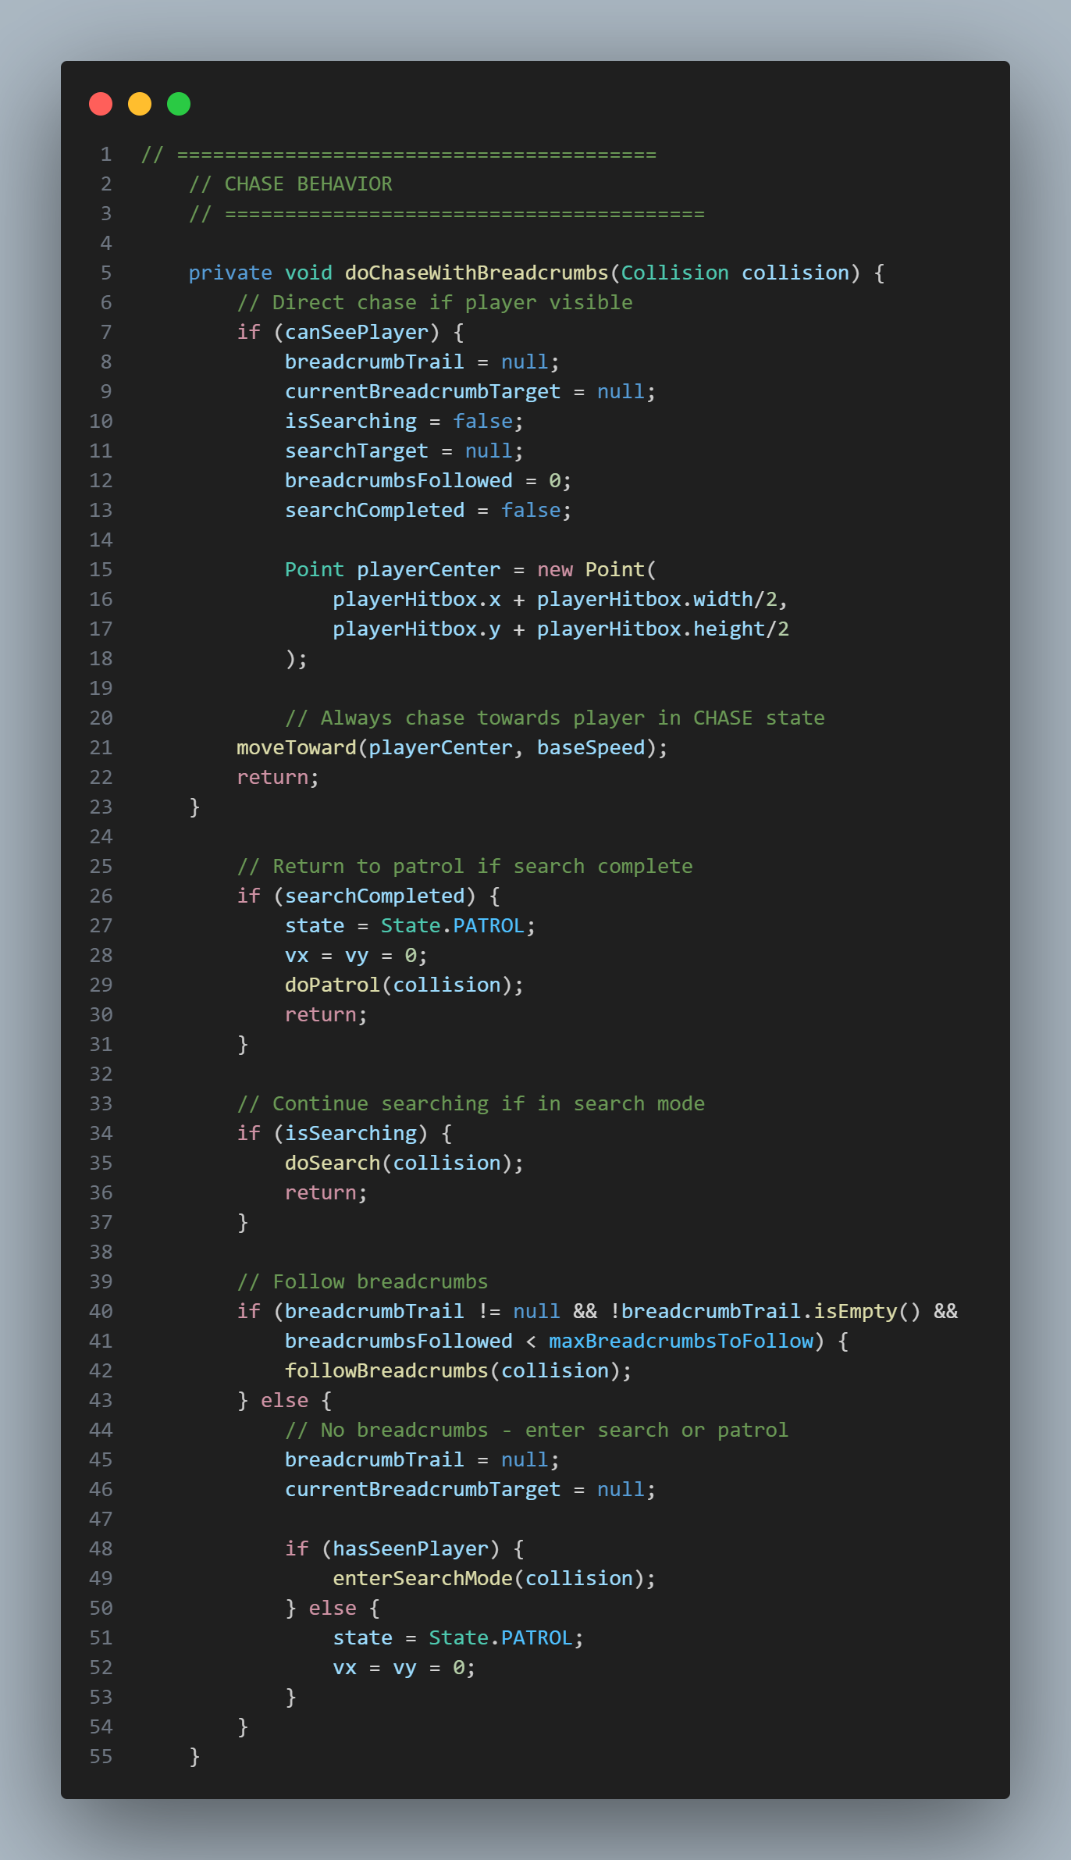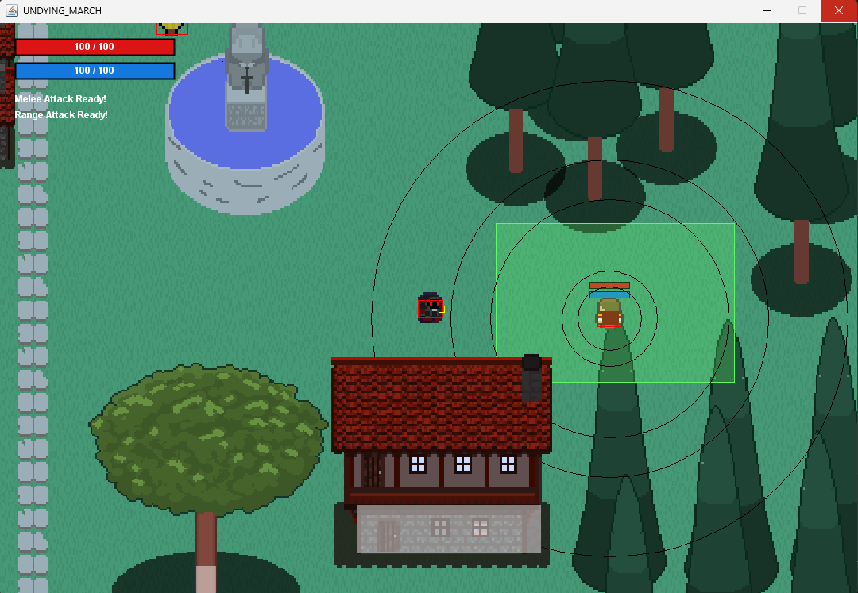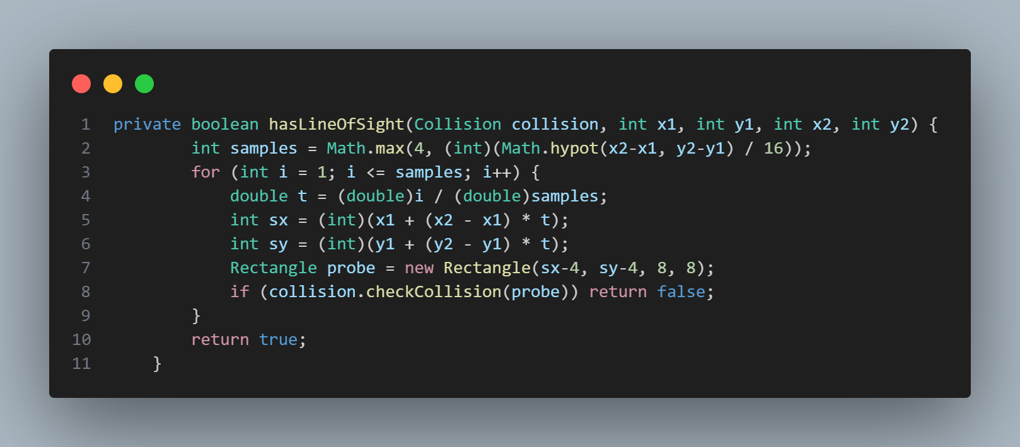

ENCOUNTERED PROBLEMS

1. INVISIBLE ENEMY HITBOX

Problem: The entire 64×64 canvas area of the enemy was receiving damage, even though only a small portion represented the visible body. This is because collision detection was using the full sprite bounds instead of the actual visible body.

Solution: Adding a body hitbox that will match to the visible appearance of the enemy so that it will properly receive the damage

2. ONE SHOT, ONE KILL

Problem: The enemy is instantly dying after getting hit by the character projectile. Same goes to the dummy, which is also keeps dying when it revives. This is because the projectile is still existing after it hit something, resulting a multiple damage in one shot to the enemy or dummy.

Solution: Adding a variable checker that will check if the projectile of the character hit something, if yes, remove it immediately.

3. NOW YOU SEE ME, NOW YOU DON'T

Problem: When the enemy is chasing the character and then suddenly the character disappear into the line of sight of the enemy, the enemy will immediately go back to its patrol zone. The cause of this is because the enemy is only chasing the character if it can see the character on his line of sight.

Solution: Implementing the breadcrumbs logic to serve as the last place the character was seen. This will be the indicator where the enemy will search before going back to its patrol zone

4. THE ENEMY WHO CAN'T BE MOVED

Problem: When the enemy is collided into an obstacles, it will be stuck into it until it sees the character. This is because the enemy only focus to its goal: chase the character or go back to its patrol zone. The enemy never cares to its surroundings.

Solution: Adding a function that will detect if the enemy is not changing a position/coordinates and if yes it will keep moving in another direction until it unstucks itself on it.

5. I SUDDENLY DON'T KNOW HOW TO PERFORM RANGED ATTACK

Problem: When the game run and after some gameplay the character ranged attack will be suddenly become unable. The reason behind this is because GamePanel updates at 60 FPS, but the Projectile class had its own timing mechanism (MOVE_INTERVAL_MS) that created timing conflicts. This desynchronization caused projectiles to stop working correctly

Solution: Removing the MOVE_INTERVAL_MS in the Projectile class.

6. GAME CRASH

Problem: After some gameplay, the game will crash and throw "ConcurrentModificationException". This is because the list of enemy, projectiles, and breadcrumbs were being modified (adding/removing elements) while simultaneously being iterated over in the game loop."

Solution: Making a copy of enemy, projectiles, and breadcrumbs list.

**Notice**

As for our task 6, summoning of minions hasn't been applied into our game, the failure to create and apply it is due to various events happened.

**Gantt Chart**

